Project Design Phase
Solution Architecture

Date | 15 February 2026
Team ID | LTVIP2026TMIDS80981
Project Name | Orderonthego : your on-demand food ordering solution
Maximum Marks | 4 Marks

Solution Architecture:
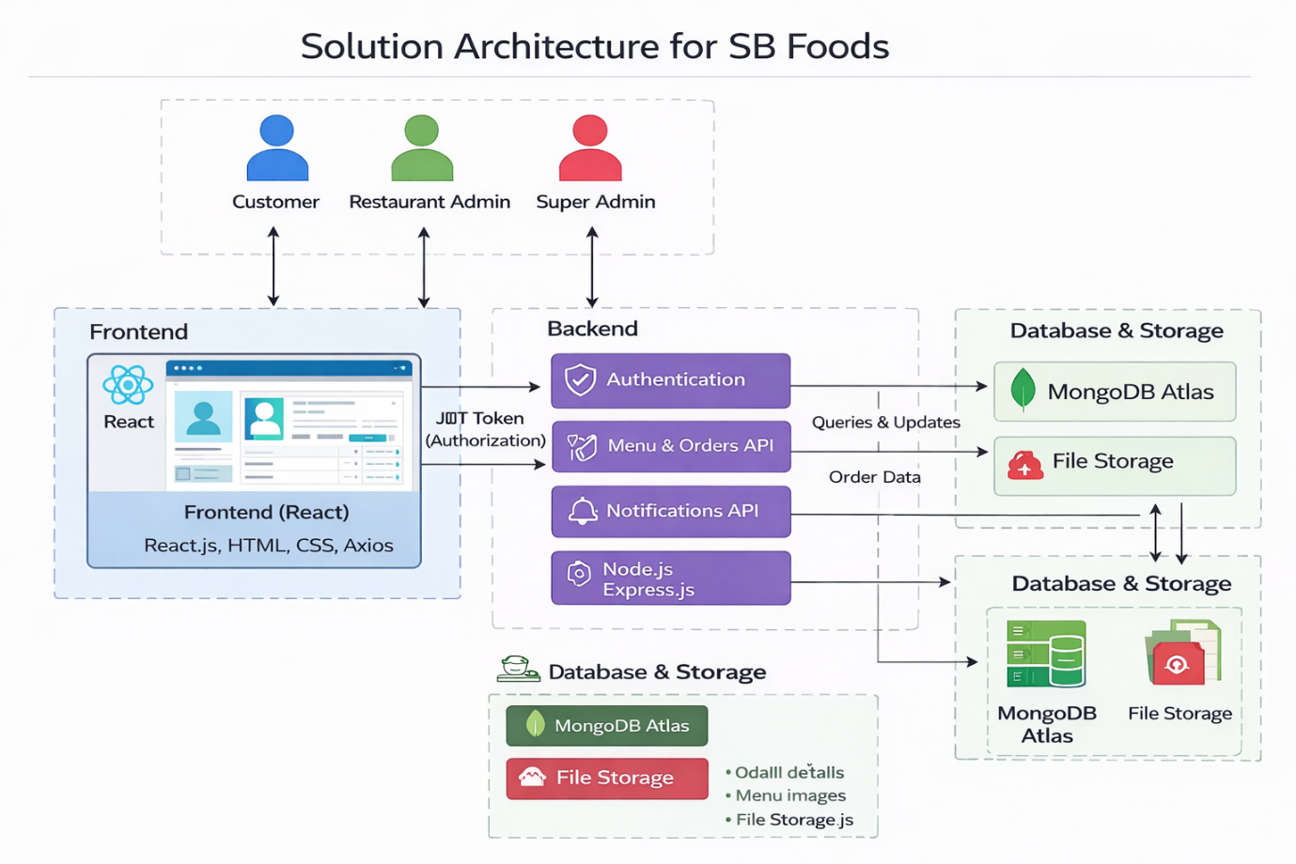
Figure-1: Architecture and data flow

